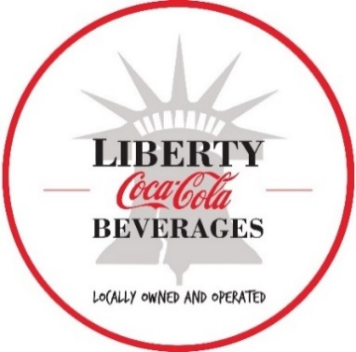

PRESS RELEASE
FOR IMMEDIATE RELEASE:
May 29, 2024

Local Coca-Cola Bottler unveils new technology with plans to replace 200,000 pounds of plastic a year
Liberty Coca-Cola Beverages teams with WestRock to replace multipack plastic rings with paperboard packaging carriers

PHILADELPHIA – Liberty Coca-Cola Beverages, a local Coca-Cola bottler serving Philadelphia, New Jersey and New York City, and WestRock (NYSE:WRK), a leading provider of sustainable paper and packaging solutions, has successfully completed the installation of new equipment and technology to begin packaging multipack bottled beverages in recyclable paperboard carriers. The new packaging, which will replace an estimated 200,000 pounds of plastic rings each year, is now starting to appear on store shelves.

WestRock designed the substrate, technology and packaging machine used to implement PETCollarTM Shield Plus into beverage packaging lines, which the local bottler installed at its Philadelphia production facility earlier this year. The durable, easy-to-hold paper-based carriers are being used to package Coca-Cola’s top brands in multipacks for 12-ounce (355 millileter) and 16.9-ounce (500 milliliter) beverages.

Liberty Coca-Cola Beverages is the first beverage distributor in the world to implement this specific type of paperboard packaging.

“The new packaging technology allows us to completely replace plastic rings with paperboard carriers for products produced at our Philadelphia facility,” said Fran McGorry, co-owner of Liberty Coca-Cola Beverages. “We expect to replace 200,000 pounds of plastic a year from our multi-state territory.”

“Liberty Coca-Cola’s commitment to innovation and advancing sustainability is truly inspiring,” said Sam Shoemaker, president, Consumer Packaging, WestRock. “At WestRock, we are proud to team with Liberty Coca-Cola to help the organization serve its customers while promoting a more circular economy.”

Local officials and business and community stakeholders joined the local bottler to unveil the new technology.

“We are proud to have a local manufacturer like Liberty Coca-Cola Beverages that continues to make investments in sustainability and improve the communities it serves,” said Councilmember Quetcy Lozada, Philadelphia City Council, 7th District. “This is an opportunity for Philadelphia to showcase Liberty’s efforts and to demonstrate that our city is committed to doing its part to better our environment for today and into the future.”

Implementing PETCollar Shield Plus packaging is the latest move Liberty Coca-Cola Beverages is making to advance sustainability. Along with being the first bottler in the United States to replace plastic rings for mini-cans, Liberty Coca-Cola Beverages was among the first Coca-Cola bottlers to produce and distribute bottles made from 100% recycled plastic (excluding cap and label) in the United States. It has also installed a sustainable compacter that significantly reduces the bottler’s carbon footprint and processes large volumes of full plastic and aluminum containers for recycling.

In addition, Liberty last year broke ground on its Quadgeneration plant at its Elmsford, New York facility. Once complete, the local bottler will generate its own electricity, heat, cooling and recovery of carbon dioxide for beverage use.

“We are proud of the strides we are making to significantly invest in technology that produces recyclable beverage containers and to be more sustainably innovative,” Fran McGorry, co-owner of Liberty Coca-Cola Beverages. “With the WestRock collaboration, we are able to be industry leaders and make this change.”

To learn more about Liberty Coca-Cola Beverages, visit https://www.libertycoke.com

###

About Liberty Coca-Cola Beverages
Liberty Coca-Cola Beverages LLC is a privately-owned bottler that operates production facilities in Philadelphia, PA, Moorestown, N.J., and Elmsford, N.Y. and sales and distribution centers in Philadelphia, PA, Marmora and South Brunswick, NJ; the Bronx, Maspeth, Elmsford, New Windsor, and Smithtown, NY. For more information, visit us at , and follow us on , , and .

About WestRock
WestRock (NYSE: WRK) partners with our customers to provide sustainable paper and packaging solutions that help them win in the marketplace. WestRock’s team members support customers around the world from locations spanning North America, South America, Europe, Asia and Australia. Learn more at .
Media Contacts:

Mayra Linares-Garcia
Liberty Coca-Cola Beverages
917-565-2153
MayraLinares@LibertyCoke.com

Robby Johnson, APR
WestRock
470-328-6397
robby.b.johnson@westrock.com

